20MCA136 – NETWORKING & SYSTEM ADMINISTRATION LAB Dept. of Computer Applications

NETWORKING & SYSTEM ADMINISTRATION LAB

Name: Vishnu Vijayakumar
Roll No: 53
Batch: B
Date: 09-05-2022

Experiment No.: 13

Aim
Write a shell script to display current date and calender.

Program

echo "Current date is $(date)" echo "Calender;"
cal

Output screenshot
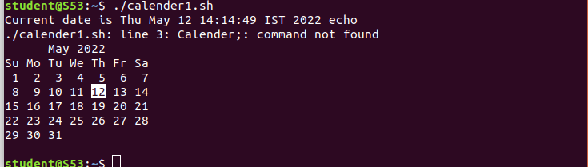

Amal Jyothi College of Engineering, Kanjirappally

